P&ID Schematic — IM4330 IO-Link Smart Sensor Training System
Functional Schematic · ISA-5.1 Style · For Training Purposes Only · Issue 1.0
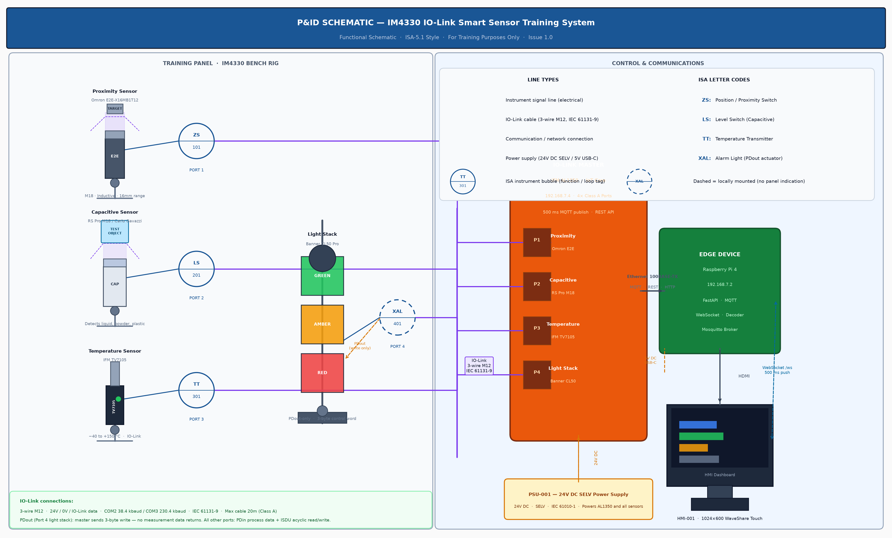

Component Register
Tag No. | ISA Code | Description | Model / Specification | IO-Link Port | Connection / Notes
ZS-101 | ZS — Position Switch | Proximity / Presence Sensor | Omron E2E-X16MB1T12 · M18 Inductive · 16mm Sn range | Port 1 | IO-Link COM3 · M12 3-wire · PDin: OUT1, monitor output, alarms
LS-201 | LS — Level Switch | Capacitive Proximity Sensor | RS Pro M18 / Carlo Gavazzi · Detects any dielectric material | Port 2 | IO-Link COM2 · M12 3-wire · ISDU: SP1 index 60/sub1
TT-301 | TT — Temperature Transmitter | Temperature Sensor | IFM TV7105 · −40 to +150 °C · PT100 element | Port 3 | IO-Link COM2 · M12 3-wire · ISDU: SP1/RP1 index 583–584, cal offset 681
XAL-401 | XAL — Alarm Light | Visual Status Indicator | Banner CL50 Pro · RGB multi-segment · PDout-only | Port 4 | IO-Link COM2 · M12 3-wire · Write-only: 3-byte PDout colour/animation
IL-001 | — | IO-Link Master | IFM AL1350 · 4× Class A · IP 192.168.7.4 | — | Ethernet 100BASE-TX to Pi · MQTT 500ms publish · REST API
EDG-001 | — | Edge Device / Controller | Raspberry Pi 4 · IP 192.168.7.2 · FastAPI · Mosquitto | — | Ethernet from AL1350 · HDMI to HMI · WebSocket to browser
HMI-001 | — | HMI Dashboard / Browser | Chromium kiosk · WaveShare 1024×600 touchscreen | — | HDMI from Pi · WebSocket /ws · 500ms live update
PSU-001 | — | 24V DC Power Supply | 24V DC SELV · IEC 61010-1 · Min 1.5A | — | Powers AL1350 and all sensors · Pi powered separately 5V USB-C

Notes: All sensors are mounted on the IM4330 training panel bench rig — there is no external process plant. All IO-Link connections are 3-wire M12 point-to-point cables (24V DC + 0V + IO-Link data, unshielded). ISA letter codes: Z=Position, L=Level, T=Temperature, X=Unclassified (alarm). Second letter: S=Switch, T=Transmitter, AL=Alarm Light (actuator). Dashed bubble (XAL-401) indicates locally mounted with no panel indication — output is write-only (PDout). ISDU (acyclic service data) read/write available on all ports via REST API POST /api/io-link/port/{n}/parameter/.

